# SOFTWARE REQUIREMENT SPECIFICATIONS

**Shortcut keys App**

**Submitted by**:

**Sonam Choki (12190080)**

1. **Introduction**

The following section provides an overview of derived software requirements specification for the Shortcut keys application. To begin with, purpose of the document is presented and scope of the project is specified with the particular focus on what the resultant software will do. The document will also include functional requirement and non-functional requirements.

The set of shortcut keys is the subject of my project. Shortcut keys Application allows users to quickly access shortcut keys from an application's list of keys, as well as add shortcut keys who are not already present. The main aim of this paper is to build a shortcut keys application that makes learning shortcut keys simple and provides a learning structure for users to study shortcut keys.

* 1. Purpose

The purpose of this document is to provide a detailed description of the Shortcut keys Application's requirements. It will show the purpose and complete declaration for the system's development, as well as the system software specifications.

* 1. Scope

The Shortcut Keys is an Android mobile application that allows users to quickly access shortcut keys and save time without having to go online. Furthermore, users can use the keyword search to find their desired phrase, and the application will show it to them.

1. **Requirements**
   1. Functional Requirements

This section describes the high level of functionality of Shortcut keys Application.

1. User Registration

When a user uses the app, they will need to register to the system.

User will need to provide information such as name, email address, and password.

1. Search

User can search for desired shortcut keys by giving hint of their word or giving keyword.

1. Add

User can add new shortcut keys which are not present in the application.

1. Report

User can report respective shortcut keys which do not word or which are repeated and also which are irrelevant added by users.

1. Exit

Registered user can exit the app when desired.

* 1. Non-functional requirements

1. Supportability

Shortcut keys application can be deployed in any android smartphone since majority of the population uses smartphones and android being the cheaper variant.

1. Availability

Shortcut keys is an application that will have as many shortcut keys as possible and make available to users.

1. Usability

The mobile application will have a user-friendly interface and it will be achieved by the use of clear text and information.

* 1. Software Requirements

App Development Tools

* Java SE jdk1.8.0_111 and above
* Android SDK-25 and above
* Android Studio version 2.3.3 and above
* Android OS 2.3(“Gingerbread”) or higher.
* Firebase

Documentation and Design Tools

* Latex
* MS Word
* Proto.io (UI Design)

1. **Hardware requirements**

* Processor: dual core 64-bit, 2GHz intel core i3
* RAM : 4GB
* Hard disk Space: 500Mb and 1GB for android SDK
* Windows 8 and above

1. **System Design**
2. Entity Relationship Diagram (ERD)

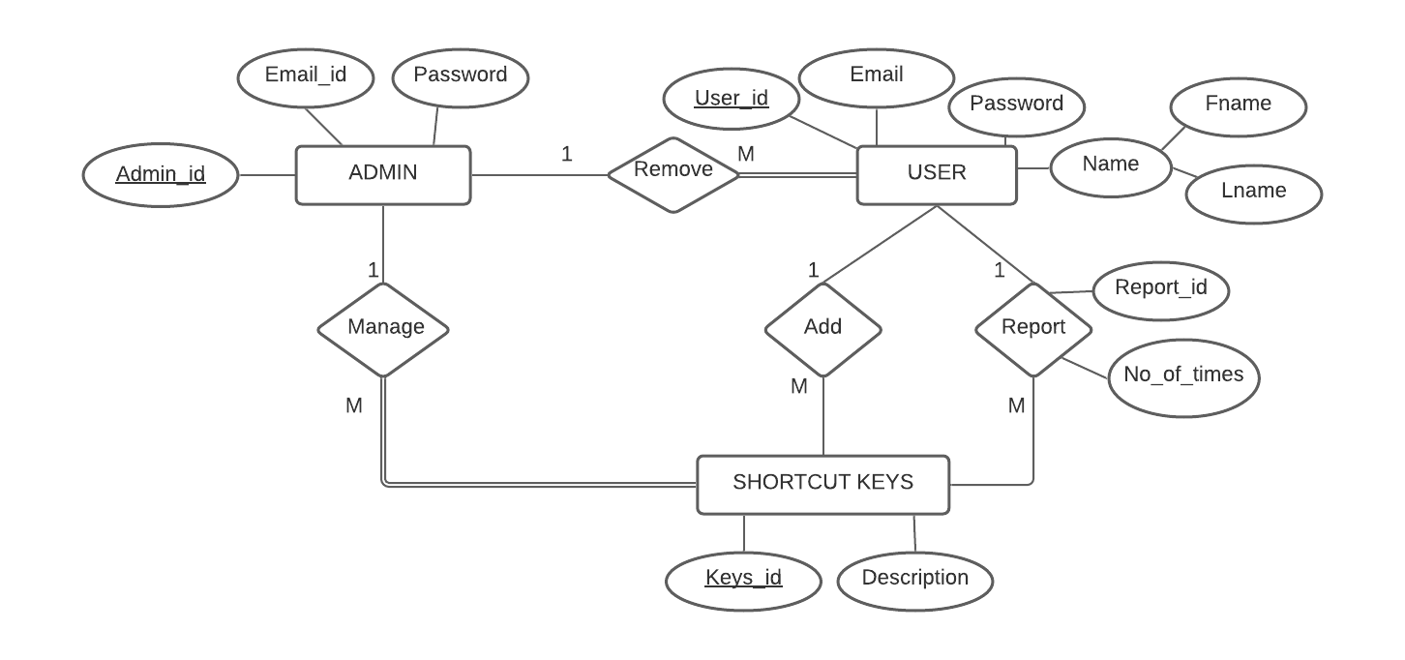

**Description:**

**ENTITY:** ADMIN, USER AND SHORTCUT KEYS

**RELATIONSHIP:** ADD, REPORT, MANAGE AND REMOVE

**USER**

USER entity has attributes like User_id, Email, Password and Name (Fname and Lname) where primary attribute is User_id. One user can add many shortcut keys and manage shortcut keys can be post by one user. One user can report many shortcut keys and many shortcut keys can be report by one user, so the cardinality ratio between user and shortcut keys is 1:M (one to many). Relationships report between user and shortcut keys have attributes like Report_id and No_of_times of report where the Report_id is a primary attribute.

**SHORTCUT KEYS**

SHORTCUT KEYS entity has attributes like Keys_id and Description where Keys_id is a primary key.

**ADMIN**

ADMIN entity has attributes like Admin_id, Email_id and Password where Admin_id is a primary key. One admin can manage (View, delete and update) many shortcut keys and admin can either manage or not whereas shortcut keys must be managed by admin so participant is total from shortcut keys to admin. Admin can either remove user or not whereas all user can be only removed admin so the participant is total from user to admin.

1. 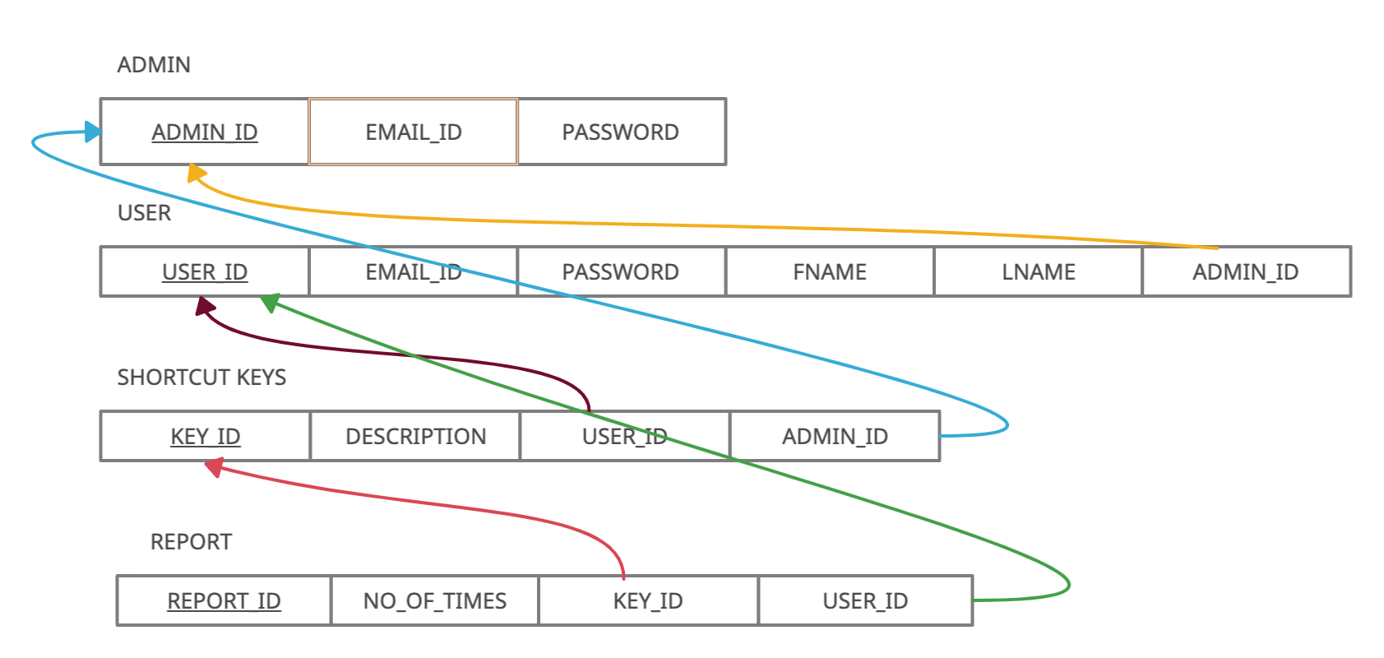Relation schema

**Description:**

**Relation name:** ADMIN, USER, SHORTCUT KEYS, AND REPORT

**Primary Key:** ADMIN_ID, USER_ID, KEY_ID AND REPORT_ID

**Foreign Key:** ADMIN_ID in USER relation, ADMIN_ID and USER_ID inSHORTCUT KEYS relation and KEY_ID and USER_ID in REPORT relation.

1. Use Case

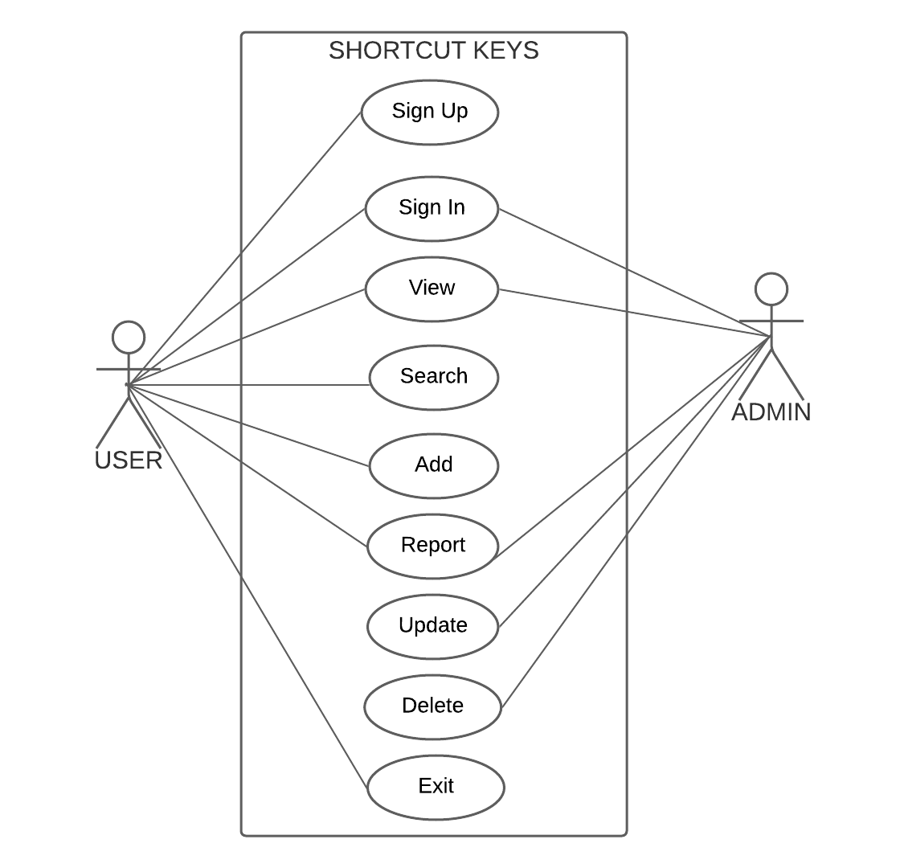

**Description:**

In shortcut keys application, there are two actors where user is a primary actor who initiates the work. Firstly, user have to sign up the application entering sudden information. After registration, user can sign in the application where user will be able to view the shortcut keys, search, add, and report shortcut keys. And then user can exit the application.

Admin is the secondary actor. Admin have to sign up the application in order to manage shortcut keys application. Admin can view the shortcut keys and also view the reports reported by users then delete the shortcut keys as well as user. Admin can also update shortcut keys.

1. 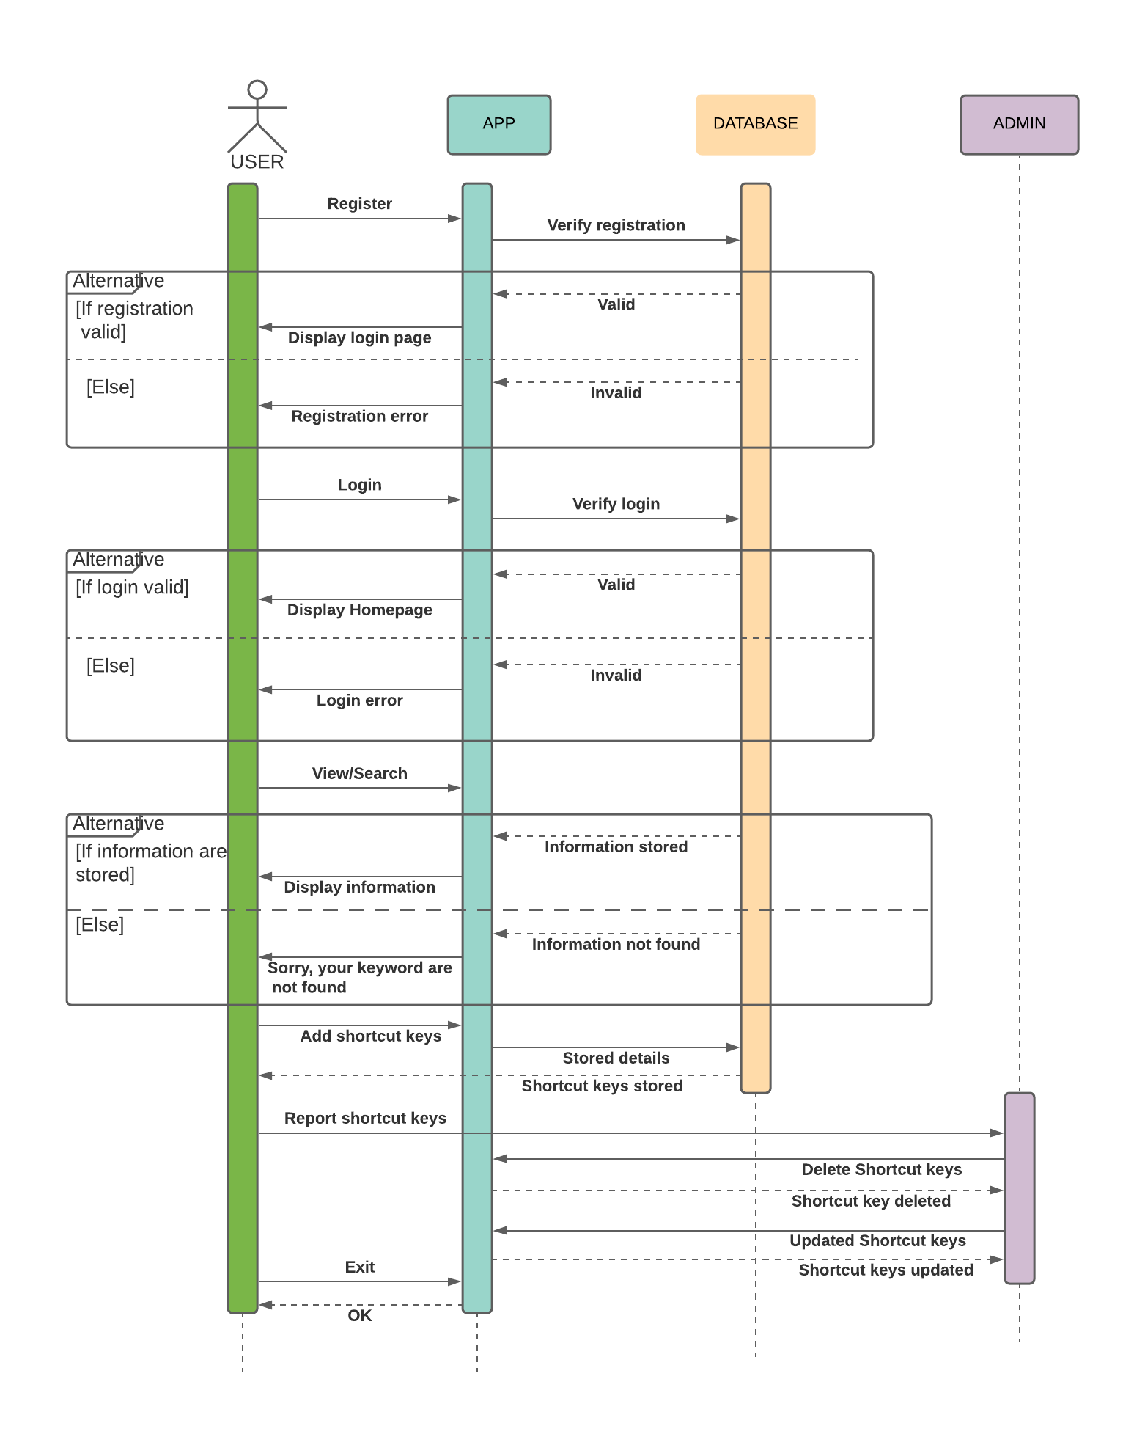Sequence Diagram

**Description:**

Firstly, user have to register the application entering their information and database will verify registration process. If the information entered by the user are verified then login page will display whereas if the registration is invalid then registration will be done again. After the registration being verified then user will login and database will verify login. If the login is error, then user have to re-enter their information, however if user login is successful then main page/homepage will be displayed where user can do sudden task.

Firstly, user can view the shortcut keys and also user can search for their respective desired word. When user enter their desired keyword, if the desired keyword is stored in the database, then it will display the keyword, shortcut key and their functions. However, if the keyword is not found then “sorry, your keywords are not found” will displayed. And user can also add the shortcut keys which are not found in application and new information will be stored in database. Moreover, user can also report irrelevant shortcut keys to admin and admin will delete the shortcut keys. Lastly, user can exit the application.

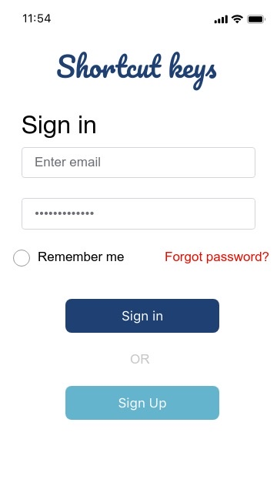**PROTOTYPE**

1. SIGN IN

When a user open Shortcut keys application for the first time, sign in page will display. If a user is an unregistered user, then user have to click Sign Up button to registered themselves for the application.

1. SIGN UP

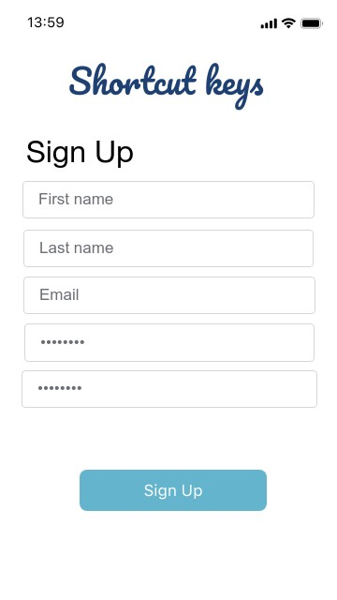

To sign up in the application, user must enter information such as First name, Last name, Email, Password and confirm password then register for the application. Then sign in page will display again then user can enter email and password and sign in the application.

1. 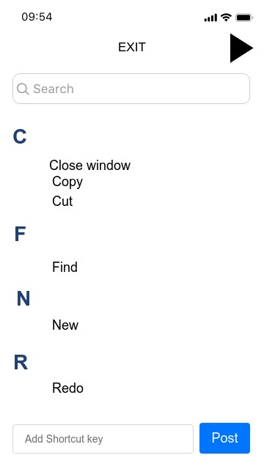MAIN PAGE / HOMEPAGE



In the homepage, user can see shortcut keys in alphabetical order. There is a search bar, next button in black triangle and add shortcut keys in the bottom of the page. There is a EXIT if user want to leave the application.

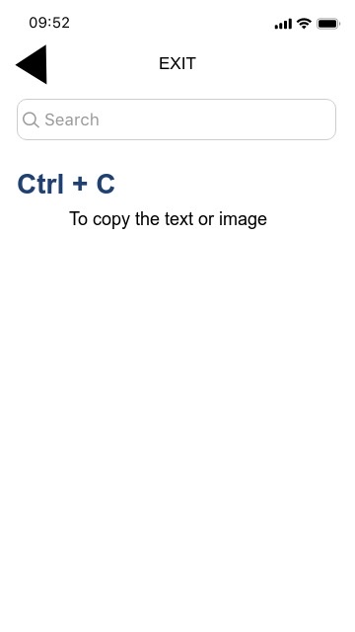

If user clicked on Copy keyword in main page, then Copy’s page will be displayed showing the shortcut key and the description as shown in the screenshot.

1. NEXT

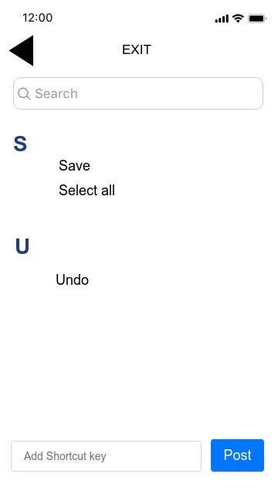

User can click Next button in order to see the shortcut keys. If a user reached at the end of shortcut keys, then there will be no Next button instead Back button will be displayed taking a user to the previous page.

1. SEARCH

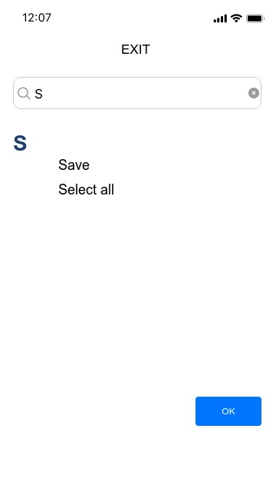

In search bar, you can enter any keyword or any letter than system will display a word that starts with the keyword or letter a user entered.

In this screenshot, user entered letter “S” and system displayed all the words that starting with that letter. User can click the respective word or if user do not find desired word, then click OK.

1. ADD

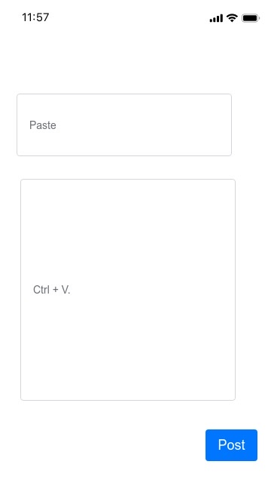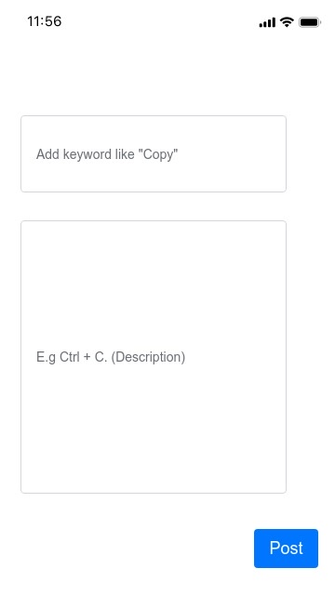

When user click the Add button, then first picture will appear giving hint to user about where to write the shortcut keys keyword and keyword’s shortcut key /description. Let’s say user entered a shortcut keys about Paste and its shortcut key and then clicked post.

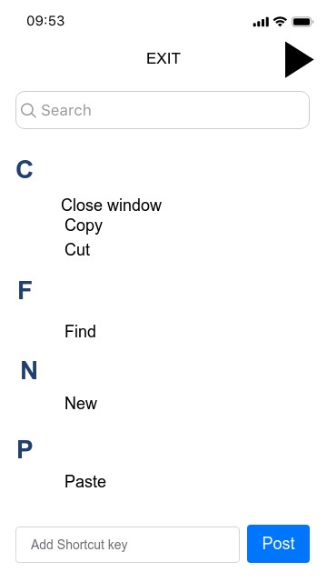

User added Paste and its shortcut key. The keyword and shortcut key will be displayed alphabetically in the shortcut key application